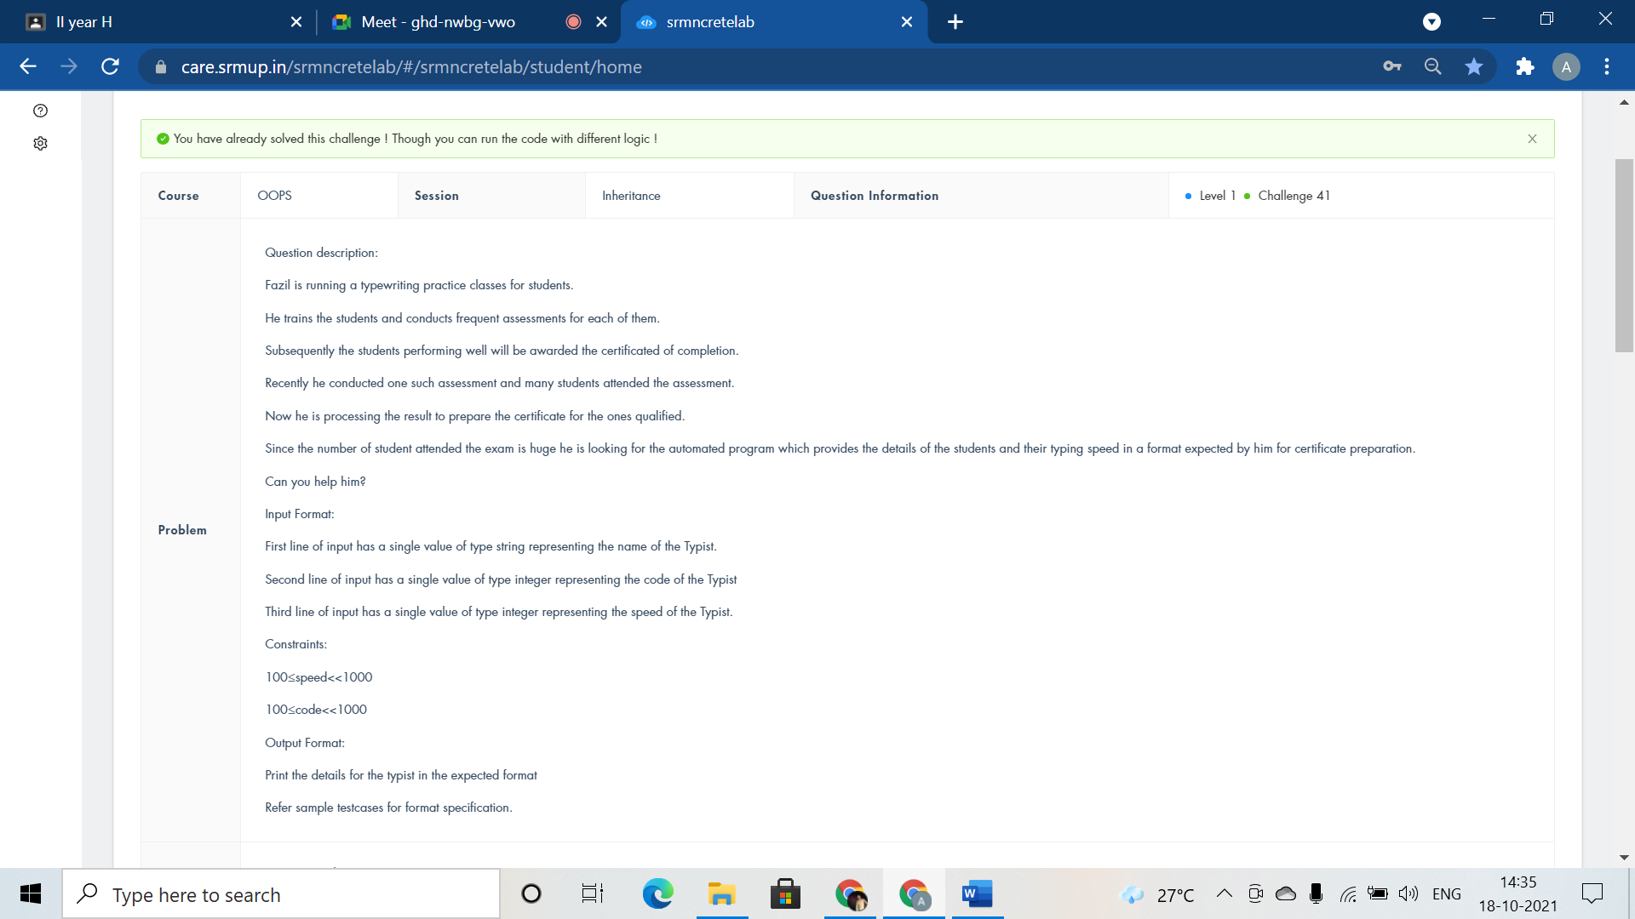

#include <iostream>

using namespace std;

class staff{

public:

int code,speed;

string name;

void getdata();

void display();

};

void staff::getdata(){

cin>>name>>code>>speed;

}

void staff::display(){

cout<<"Name:"<<name<<endl<<"Code:"<<code<<endl<<"Speed"<<speed;

}

class typist: public staff{

public:

void getdata();

void display();

};

void typist::getdata(){

cin>>name>>code>>speed;

}

void typist::display(){

cout<<"Name:"<<name<<endl<<"Code:"<<code<<endl<<"Speed:"<<speed;

}

int main()

{

typist t;

t.getdata();

t.display();

return 0;

}

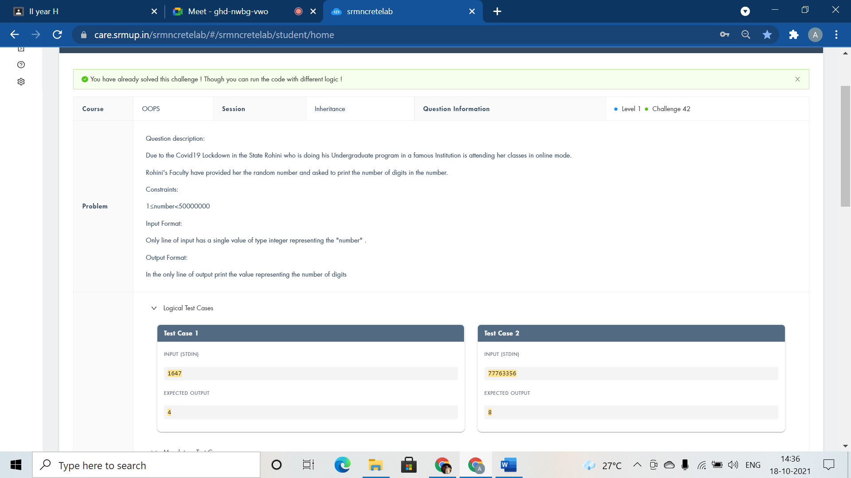

#include <iostream>

using namespace std;

class Assignement{

public:

int num;

void get(){

cin>>num;

}

void display(){

int count=0;

while(num!=0){

count++;

num/=10;

}

cout<<count;

}

};

class Student:public Assignement{

};

int main()

{

Student obj;

obj.get();

obj.display();

return 0;

}

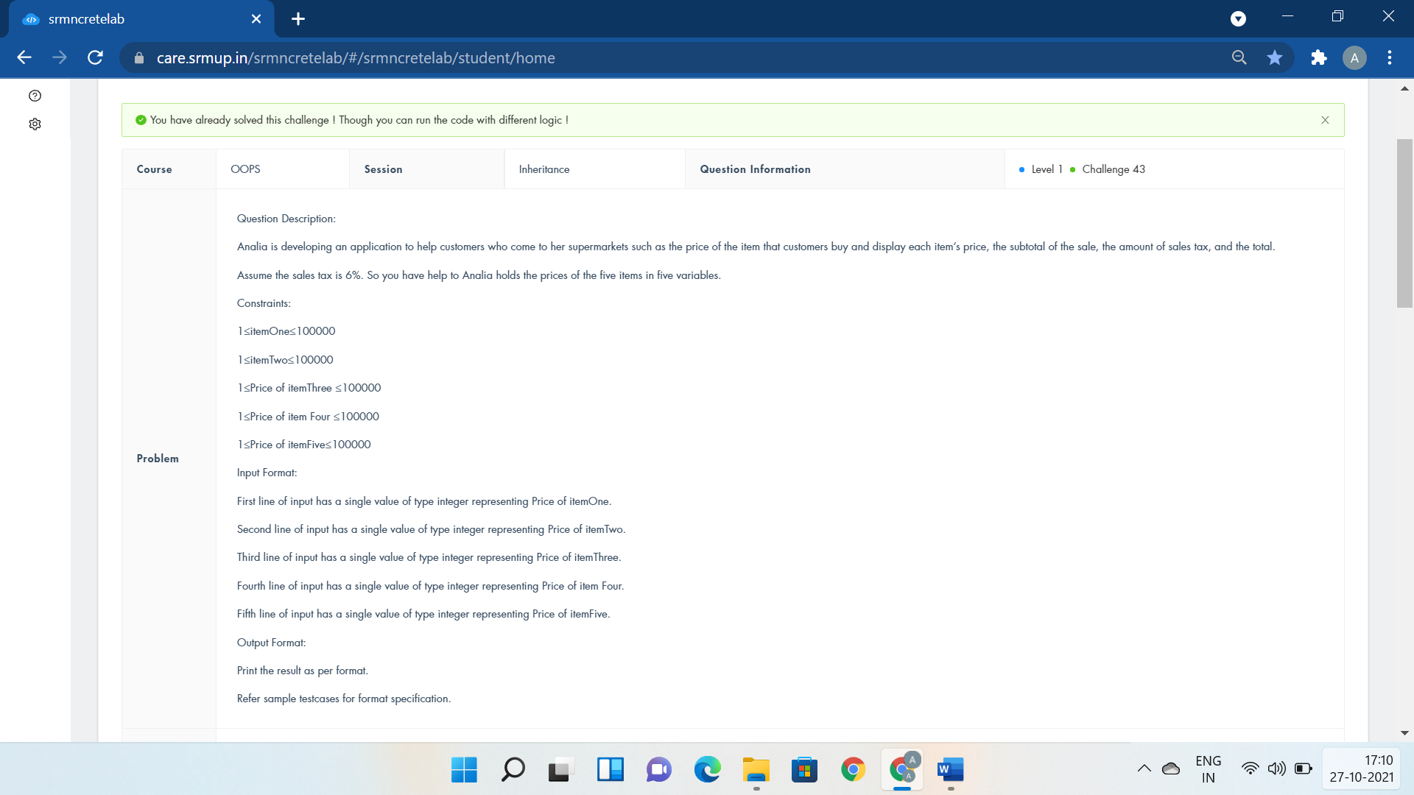

#include <iostream>

using namespace std;

class market{

public:

float i1,i2,i3,i4,i5;

float Subtotal,tax;

void items(){

cin>>i1>>i2>>i3>>i4>>i5;

}

void buy(){

Subtotal=(i1+i2+i3+i4+i5);

cout<<"Subtotal=$"<<Subtotal<<endl;

tax=0.06\*i1+0.06\*i2+0.06\*i3+0.06\*i4+0.06\*i5;

cout<<"Tax=$"<<tax<<endl;

cout<<"Total=$"<<Subtotal+tax;

}

};

class customer:public market{

};

int main()

{

customer c;

c.items();

c.buy();

}

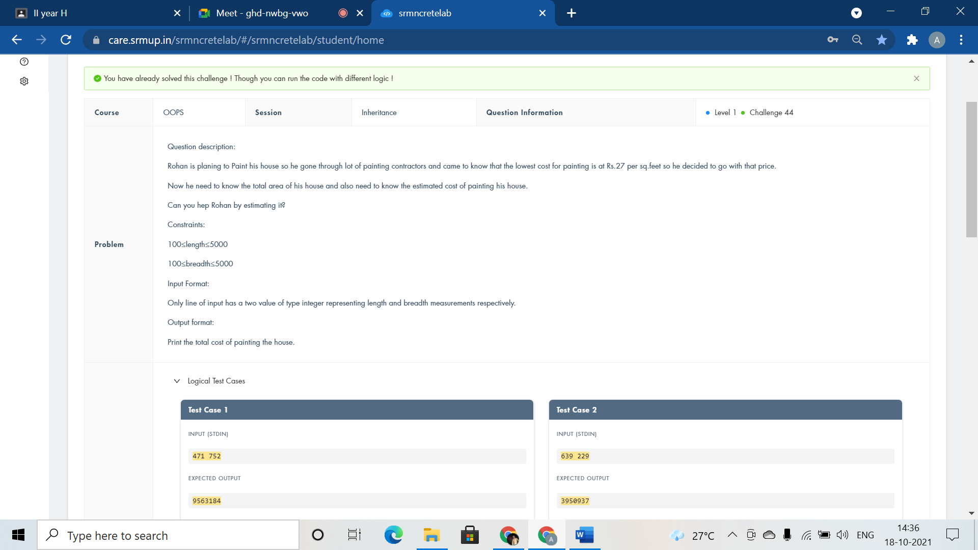

#include <iostream>

using namespace std;

class ReceiveMesurement{

public:

int l,b;

void painingarea(){

cin>>l>>b;

cout<<l\*b\*27;

}

};

class CalculateArea : public ReceiveMesurement{

};

int main()

{

CalculateArea mt;

mt.painingarea();

return 0;

}

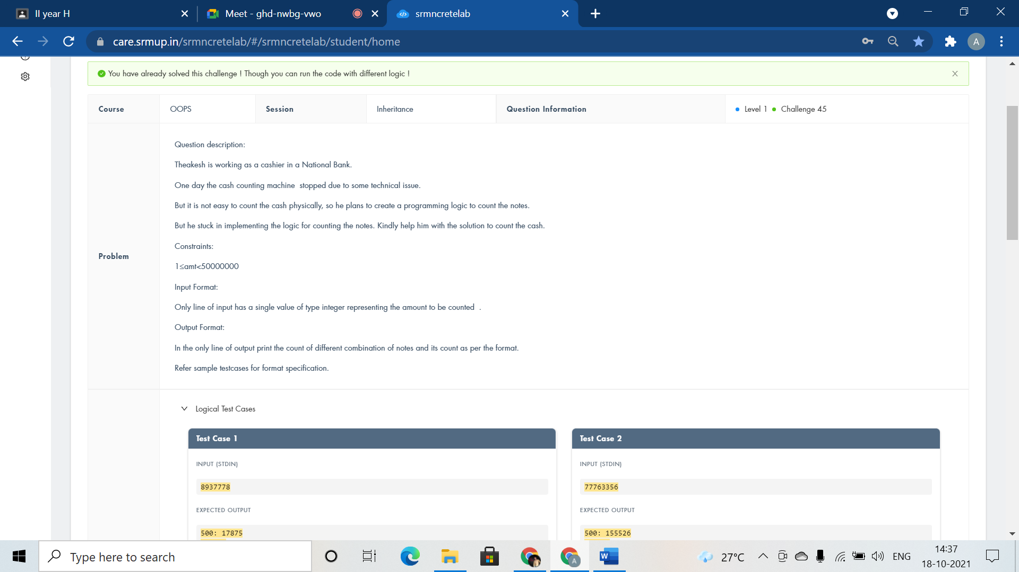

#include <iostream>

using namespace std;

class Bank{

public:

int n;

void get(){

cin>>n;

}

void display(){

cout<<"500: "<<n/500<<endl;

n=n%500;

cout<<"200: "<<n/200<<endl;

n=n%200;

cout<<"100: "<<n/100<<endl;

n=n%100;

cout<<"50: "<<n/50<<endl;

n=n%50;

cout<<"10: "<<n/10<<endl;

n=n%10;

cout<<"5: "<<n/5<<endl;

n=n%5;

cout<<"1: "<<n<<endl;

}

};

class CashCounting:public Bank{

};

int main()

{

CashCounting obj;

obj.get();

obj.display();

return 0;

}

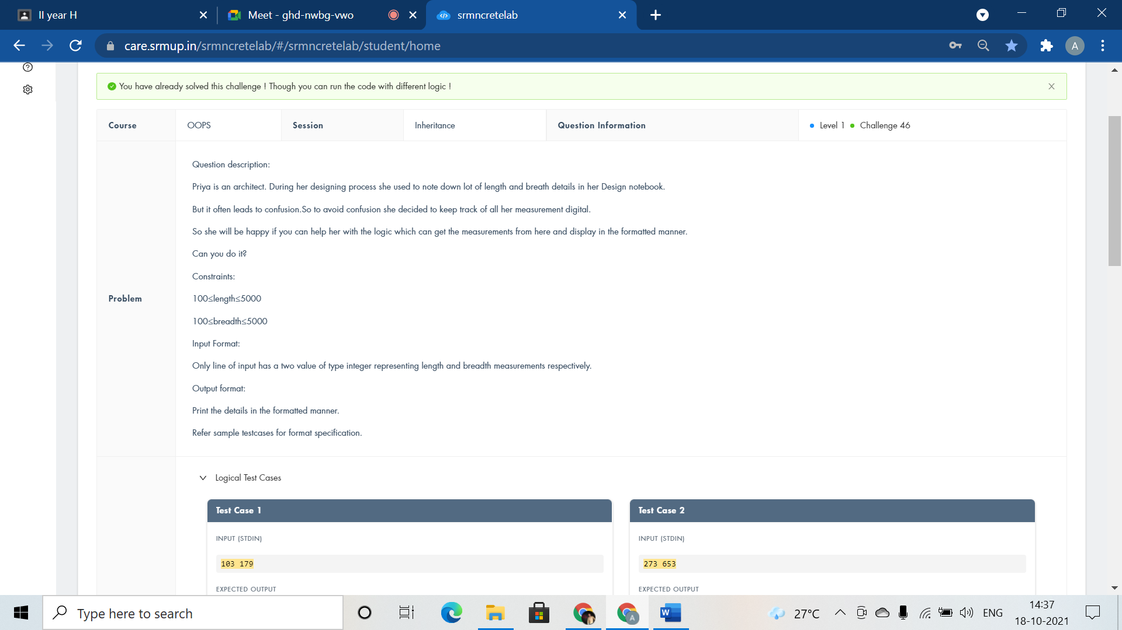

#include <iostream>

using namespace std;

class ReceiveMesurement{

public:

int l,b;

void display(){

cin>>l>>b;

cout<<"Length:"<<l<<" metres"<<endl;

cout<<"Breadth:"<<b<<" metres";

}

};

class FormatMesurement : public ReceiveMesurement{

};

int main()

{

FormatMesurement mt;

mt.display();

return 0;

}

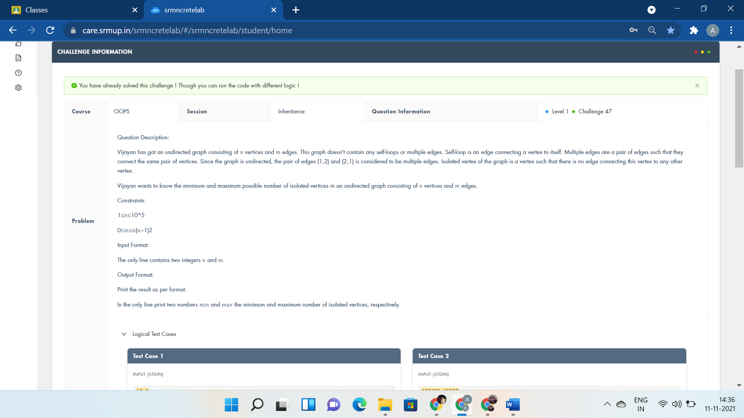

#include <bits/stdc++.h>

using namespace std;

class graph{

public:

void edge(){

}

};

class pairs:public graph{

public:

long long int n,m,k=0;

void vertex(){

cin>>n>>m;

cout<<max(0ll,n-2\*m)<<" ";

while(k\*(k-1)/2<m) k++;

cout<<n-k<<endl;

}

};

int main()

{

pairs pa;

pa.edge();

pa.vertex();

return 0;

}

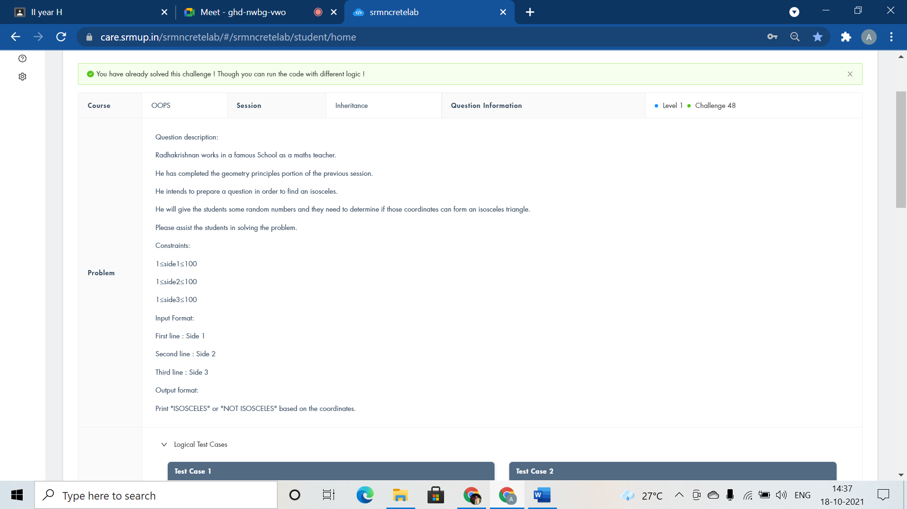

#include <iostream>

using namespace std;

class triangle{

public:

int a,b,c;

void read(){

cin>>a>>b>>c;

}

void check(){

if(a==b || b==c || a==c)

cout<<"ISOSCELES";

else

cout<<"NOT ISOSCELES";

}

};

class isosceles : public triangle {

};

int main()

{

isosceles obj;

obj.read();

obj.check();

return 0;

}

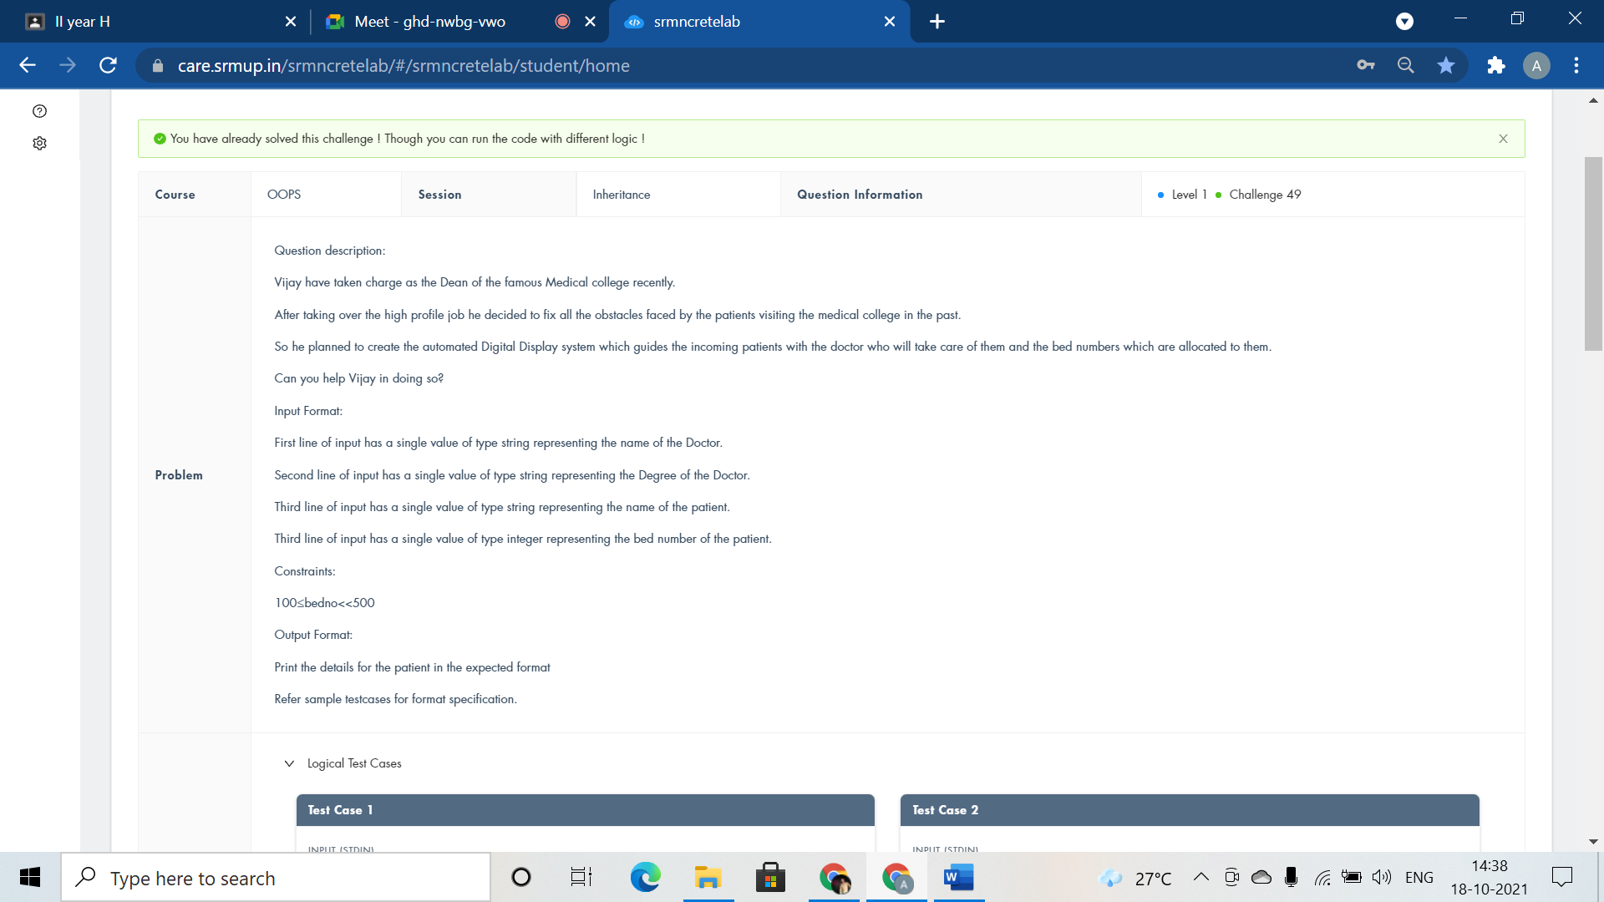

#include <iostream>

using namespace std;

class doctor{

public:

string name,degree,pname;

int no;

void getedu(){

cin>>name>>degree>>pname;

}

void getdata(){

cin>>no;

}

void dispedu(){

cout<<"Doctor Name:"<<name<<endl<<"Doctorate Degree:"<<degree<<endl<<"Patient Name:"<<pname<<endl;

}

void dispdata(){

cout<<"Bed Number:"<<no;

}

};

class patient:public doctor{

};

int main()

{

patient p;

p.getedu();

p.getdata();

p.dispedu();

p.dispdata();

return 0;

}

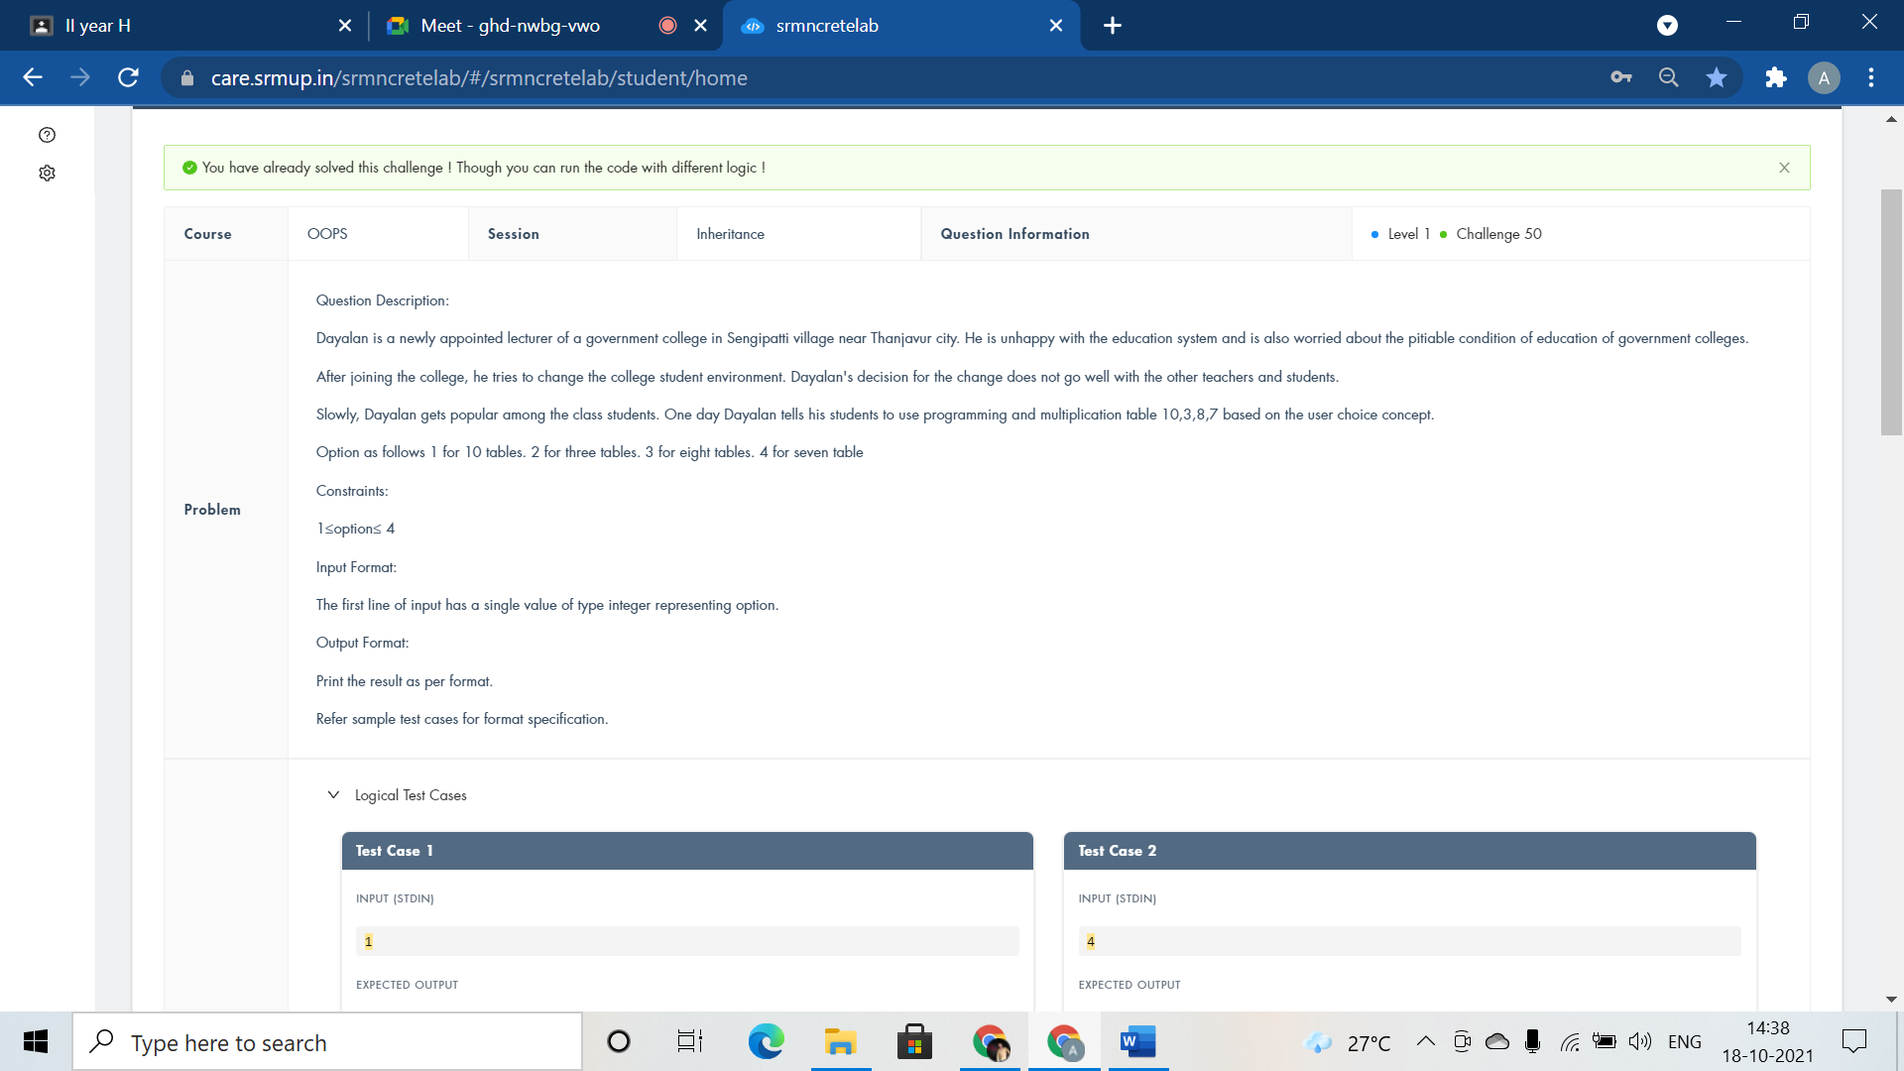

#include <iostream>

using namespace std;

class teacher{

public:

int num;

void setdata(int n)

{

if(n==1)

num=10;

else

num=7;

}

void setdata2(int n)

{

if(n==2)

num=3;

else

num=8;

}

void tentable(){

for(int i=1;i<=10;i++)

cout<<num<<"\*"<<i<<"="<<num\*i<<endl;

}

};

class ten:public teacher{

};

class three:public teacher{

};

class eight:public teacher{

};

class seven:public teacher{

};

int main()

{

int n;

cin>>n;

teacher t;

if(n==1 || n==4)

t.setdata(n);

if(n==2 || n==3)

t.setdata2(n);

t.tentable();

return 0;

}